Pine Labs Payment Gateway iOS SDK Integration V1.0

CONTENTS

CONTENTS
- About This Guide
  - Objectives and Target Audience
  - Connecting to the Payment Gateway through IOS SDK
  - Related Documentation
- iOS SDK Payment Flow
  - Flow Diagram
- SDK Integration
  - Step 1 SDK Installation and Setup
For Swift:
For Objective-C:
  - Step 2 Initialization
  - Step 3 Initiate Payment
  - Step 4 Handling call back from Pine Labs SDK.
- Transaction Verification

- About This Guide

Objectives and Target Audience

This guide provides the details on how to connect merchant‘s iOS application with Pine Labs payment gateway and use its services. It is intended for users who want to carry out integration with payment gateway.

Connecting to the Payment Gateway through IOS SDK

When customer selects make payment or pay now in iOS app, merchant app needs to call the Pine labs IOS SDK interface which contains information about the payment such as MID, Order Id, Amount to be paid and other several fields.

Related Documentation

This guide should be used together with the additional documents as described below.

Document | Description
Pine Labs payment gateway integration guide.pdf | Payment gateway Integration guide

- iOS SDK Payment Flow

- Step 1 : On click of make payment/pay now button,order payload is passed to merchant server by the app.

- Step 2: Order payload is used to generate checksum by Pine Labs server side utility and secret key(merchant key)on your server. Secret key is shared by Pine labs with merchant. Checksum is a signature used by Pine Labs to ensure the integrity of request.

- Step 3 : Merchant server pass the payload , Dia secret and Dia secret type back to app .Merchant apps pass all the details to Pine Labs IOS sdk.

- Step 4 : Pine Labs SDK accepts and forward the payload to Pine Labs payment gateway.

- Step 5 : Pine labs payment gateway verifies the payload and accept/denied the request. If payload is valid payment options will be displayed.

- Step 6 : Once the customer fill the payment details and complete the payment, then merchant app is notified via call back.

- Step 7 : Merchant verifies the transaction status with transaction status API via server to server call.

Flow Diagram

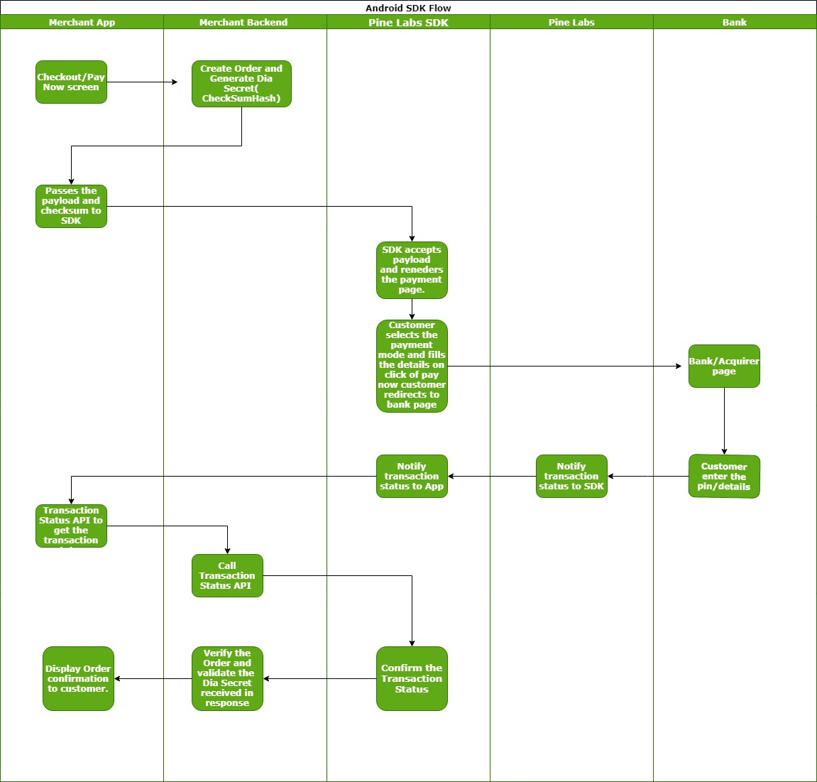

- SDK Integration

Step 1 SDK Installation and Setup

For Swift:
- Download the SDK and unzip it.
- Open your project in Xcode and go to file under Menu. Select Add files to “your project".
- Select PinePGSDK.framework in the directory you just unzipped.
- Select the Copy items if needed check-box.
- Click Add.
- Navigate to Target settings > General and add the PinePG.framework in both Embedded Binaries and Linked Frameworks and Libraries.

For Objective-C:
- Download the SDK and unzip it.
- Open your project in Xcode and go to file under Menu. Select Add files to “your project".
- Select PinePGSDK.framework in the directory you just unzipped.
- Select the Copy items if needed check-box.
- Click Add.
- Navigate to Target settings > General and add the PinePGSDK.framework in both Embedded Binaries and Linked Frameworks and Libraries.
- Go to Project Settings.
- Select Build Settings - All and Combined from the Menu of the project settings.
- Under Build Options set Always Embed Swift Standard Libraries option to TRUE.

Notes:

Ensure that you have the framework added in both Embedded Binaries and Linked Frameworks and Libraries under Target settings - General.

For Xcode 11, ensure that you have the framework added in Frameworks, Libraries, and Embed Content under Target settings - General. Change Embed status from - 'Do not Embed' to 'Embed & Sign'.

Step 2 Initialization

Object Service : To initialize the Pine Labs SDK ,create the service object
var service=new PinePGPaymentManager();
Object order : Stores all order related information which are required to be passed by you to Pine Labs. Order object is created by following code snippet

var orderParams= Dictionary<String,String>();
orderParams[“ppc_UniqueMerchantTxnID”] = ”Order ID 123";
orderParams[“ppc_MerchantID”]="34133";
orderParams[“ppc_Amount”] ="12345";
orderParams[“ppc_MerchantAccessCode”] ="58ad283b-7c93-4f19-b072-b17e8ecfb20e";
orderParams[“ppc_NavigationMode]="2";
orderParams[“ppc_TransactionType”]= "1";
orderParams[ppc_LPC_SEQ” ] ="1";
orderParams[“ppc_Product_Code”]="40";
orderParams[“ppc_PayModeOnLandingPage”]="1,3,4,7";
orderParams[“ppc_CustomerEmail”]="test@pinelabs.com";
orderParams[“ppc_CustomerMobile”] ="9876543210";
orderParams[“ppc_CustomerId”]="123";
orderParams[ppc_CustomerAddress1”] = "Noida B block";
orderParams[“ppc_CustomerAddressPIN”]="201301";
orderParams[“ppc_DIA_SECRET”]= “w2QDRMgp1234567JEAPCIOmNgQvsi+BhpqijfM9KvFfRiPmGSt3Ddzw+oTaGCLneJwxFFq5mqTMwJXdQE2EzK4px2xruDqKZjHupz9yXev4";
orderParams[“ppc_DIA_SECRET_TYPE”]=”SHA256”;

Parameter details can be found in Purchase request section 6.3.1.3 Pine Labs payment gateway integration guide.pdf

Step 3 Initiate Payment

Public class MerchantCallbackResponse:IPinePGResponseCallback
{

public func internetNotAvailable(code:int,message:String) {}

public func onErrorOccured(code:int,message:String) { }

public func onTransactionResponse() {}

public func onCancelTxn(code:int,message:String) {}

public func onPressedBackButton(code:int,message:String) {}
}

Parameters used in start Payment in order are –

- context : context of your Activity is where this method is called.
- iThemeIdVal: A Integer variable(possible value 0,1,2) to apply theme on Pine labs SDK.
- isHeaderTobeShow : A Boolean variable (true/false) to hide or show header bar.
- Environment : A Integer variable (0-for uat,1-for production,2-for testing) to determine whether request is for production environment .
- IPinePGResponseCallback : IPinePGResponseCallback instance to send call back messages back to merchant iOS app.

Step 4 Handling call back from Pine Labs SDK.

You need to implement call back methods to handle payment response. This will provide the payment status and reason for transaction failures. Based on the reasons for failures, handling can be built at your end. Transaction call backs can be listened via overriding methods of IPinePGResponseCallback.

onTransactionResponse method is called when transaction is complete. Transaction can be fail or success.

internetNotAvailable method is called when internet is not available.

onErrorOccured method is called when SDK is unable to load the payment a page.

onPressedBackButton method is called when user press the back button

onCancelTxn method is called when user cancels the transaction.

- Transaction Verification

It is the Rest API used to get the transaction status of the transaction. Merchant needs to call this api after receiving callback of transation.

Parameter details can be found in dependent transaction request section 6.4 Pine Labs payment gateway integration guide.pdf

